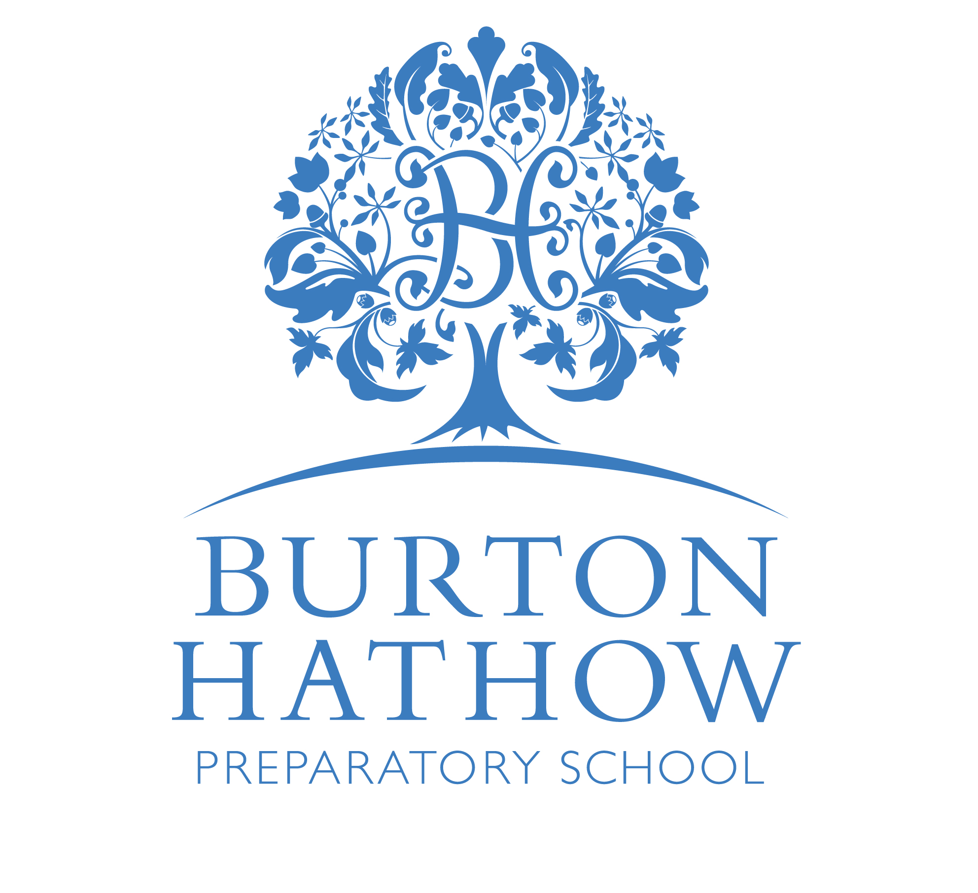
BURTON HATHOW PREPARATORY SCHOOL
Term Dates 2024-25
Autumn Term (1) | Wednesday 4th September 2024 to Friday 18th October 2024  Holiday: Saturday 19th October 2024 to Sunday 3rd November 2024
Autumn Term (2) | Monday 4th November 2024 to Wednesday 18th December 2024  Holiday: Thursday 19th December 2024 to Monday 6th January 2025  Includes Public Holidays: Wednesday 25th December, Thursday 26th December,  Wednesday 1st January
Spring Term (1) | Tuesday 7th January 2025 to Friday 14th February 2025  Holiday: Saturday 15th February 2025 to Sunday 23rd February 2025
Spring Term (2) | Monday 24th February 2025 to Friday 4th April 2025  Holiday: Saturday 5th April 2025 to Monday 28th April 2025  Includes 2 Public Holidays: Friday 18 ^{th} April (Good Friday) and  Monday 21st April (Easter Monday)
Summer Term (1) | Tuesday 29th April 2025 to Friday 23rd May 2025  Includes 1 Public Holiday: Monday 5 ^{th} May – May Day Bank Holiday  Holiday: Saturday 24th May 2025 to Sunday 1stJune 2025  Includes 1 Public Holiday: Monday 26th May – Spring Bank Holiday
Summer Term (2) | Monday 2nd June 2025 to Friday 11th July 2025  School Closed Thursday 19th June 2025 for Lincolnshire Show
Staff Training Days | Monday 2nd and Tuesday 3rd September 2024  Monday 6th January 2025 Monday 28th April 2025

