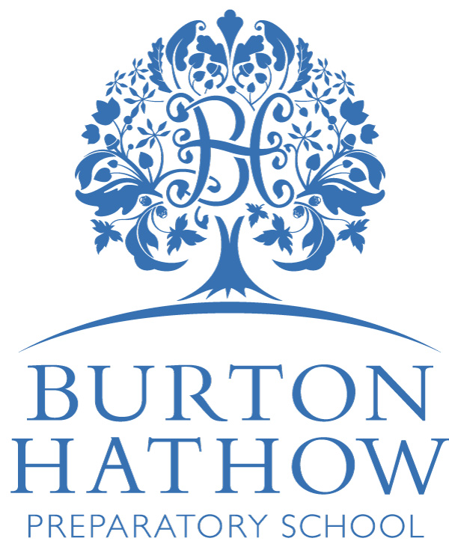

Curriculum Policy

Burton Hathow Preparatory School Including Early Years

INTRODUCTION
Burton Hathow Preparatory School aims to provide a broad and balanced curriculum which is accessible by and relevant to all its children including any for whom English is a second language and those with an EHC or IEP. The school seeks to give appropriate learning opportunities to all pupils within the core curriculum and, importantly, not to limit their opportunities according to previous experience and ability. We aim to encourage their personal development in all areas and equip them to cope with life in modern Britain or further afield.

Burton Hathow provides its pupils with an experience in linguistic, mathematical, scientific, technological, human and social, physical, and aesthetic and creative education as set out below.
• Linguistic. This area is largely addressed by the core English curriculum which provides for teaching and progression in reading, writing, speaking and listening. Further opportunities for learning occur through spoken-language clubs after school or by entering the Lincoln Festival of Music and Drama. There are scheduled school dramatic productions which may be filmed or performed live and these enable pupils to develop their spoken skills. World Book Days, theatre visits, poetry competitions, readathons and handwriting activities are held to provide additional stimulus. Writing skills are also rehearsed across the curriculum. Linguistic skills are further taught and encouraged through the teaching of foreign languages: Spanish is taught from Early Years and French is an optional extra –curricular activity for Year 6 in the Summer Term. English as an Additional Language (EAL) students are supported in class though they are also expected to integrate into the school by speaking English within school time. The presence of non-English speakers encourages all pupils to see the value of learning a foreign language and the value of their different culture.
• Mathematical. This area is largely addressed by the core Maths curriculum which provides for making calculations, understanding and appreciating relationships and patterns in number and space, developing a capacity to think logically and express thoughts clearly. Mathematical skills are also addressed where appropriate in other areas such as Science, Design & Technology (DT), Information Communications Technology (ICT) and Geography. More able pupils have the opportunity to take part in the Mathematical Association ‘Maths Challenge’.
• Science. This area is largely addressed by the core science curriculum which covers a wide range of topics within the traditional areas of Biology, Chemistry and Physics. The development of science skills, such as enquiry, observation, forming hypotheses, conducting experiments and recording findings and research also form an important part of the science curriculum. Pupils are encouraged to apply their scientific knowledge to the world around them and to appreciate explanations as to why things are the way they are.
• Technological. This area is largely addressed by the core curriculum in ICT and DT. It is also supported by the Science curriculum, the Forest School and in Music. Children are taught ICT throughout the curriculum where they use a range of applications including word-processing, multimedia, modelling, control, Internet and email skills, spreadsheets, databases, and iPad usage. ICT skills sessions are built into the curriculum when necessary and pupils in Year 3 upwards have a designated programming lesson. DT is taught as part of an integrated programme with Art and pupils are given the opportunity to use tools and materials of different types, to plan and evaluate their own and others work and to consider processes and products. This is often extended by work undertaken on separate DT and Outdoor Days of which there is usually one per term for pupils in Key Stages One and Two. Food technology forms an important part of this process, in KS1 food technology is taught separately, in KS2 this forms part of the English curriculum with a focus on instructions. Programming is also taught as a separate subject from Year 1 upwards. Pupils in Year 4 upwards are encouraged to have their own iPads and these are widely used as a tool in lessons and to aid homework dissemination and completion.

• Human and Social. This area is largely addressed by the core curricula in History, Geography and Religious Education (RE). Personal, Social, Health and Economic Education (PSHEE) also plays a role. Pupils are encouraged to recognise links within the curriculum so that they can begin to appreciate how human action now and in the past has influenced the planet and its development. Pupils are taken on a variety of trips and meet a number of visiting speakers to develop their awareness of history, the physical environment and religious practices. In more general terms pupils are taught about issues such as the environment, racism, world poverty, setting and achieving personal goals and living as a community. This is done in a variety of ways including through assemblies and by the school ethos. PSHEE is taught during one morning period per week and assembly also forms an important medium for discussing PSHEE related issues.
• Physical. This area is largely addressed by the core curricula in Physical Education (PE) and Games supported by extra-curricular activities, for example in tennis, football, rugby and striking and fielding games. PE and Games lessons aim to develop pupils' physical control and co-ordination, their team skills, tactical ability and ability to evaluate and improve their performances in a wide variety of team and individual sports. Pupils are also taught about the basic principles of fitness and health and are encouraged to adopt a healthy attitude through teaching in food technology and science about diet. From the age of 7 pupils have many opportunities to play competitively against teams from their own and other schools and pupils of all abilities are encouraged to take part. Children from Year 1- Year 6 each receive a term of swimming lessons. The ‘Motor Movers’ programme is utilised throughout school as necessary to aid pupils’ development.

- Aesthetic and creative. This area is largely addressed by the core curricula in art and music with important contributions from PE, ICT, and English. However, many subjects have a creative aspect and pupils are encouraged to explore and develop their creativity and their individual talents throughout the curriculum and in accordance with their skills and abilities. Teachers seek to be aware of the talents of individual pupils and to foster them wherever possible both in formal lessons and in the wider school environment such as during extra-curricular activities and whole school contexts which may include, school productions, Drama festivals, concerts, school music groups, art club etc. All children are encouraged to learn a musical instrument just as all are encouraged to participate in the school choirs. All pupils in Year 3 upwards do participate in group music making as part of the orchestral programme which we believe is a particularly valuable feature of the School and contributes greatly to pupils’ development in a wide range of skill areas.

Speaking, Literacy, Listening and Numeracy

Literacy skills are addressed primarily through the English curriculum but are, of course, reinforced in areas across the whole school – particularly in subjects such as History and Geography where extended written work may form a significant part of the programme of study. Speaking skills are developed all through the curriculum through question and answer based activities that are the ‘bread and butter’ of so many lessons as well as more specifically focussed tasks such as the preparation and delivery of presentations.
Listening skills are particularly highly prized at Burton Hathow. Good listening habits are constantly reinforced and during all lessons. The Autumn and Spring Term Grade Reports include a particular reference to listening skills as a testament to how important we feel this is.
Numeracy skills are addressed primarily through the Maths curriculum but also regularly reinforced in subjects such as Science where some topics have a significant mathematical component.

Personal, Social, Health and Economic Education

We believe that a strong PSHE education is important to help our pupils develop into well-rounded members of society, who are able to make a positive contribution to their community and . At BHPS our PSHE curriculum is strongly tied to our sex and relationship education (SRE) and pastoral care programme.

The main aims of the PSHE course are to:

- Understand what constitutes a healthy lifestyle.
- Understand safety issues, both in real life and online.
- Develop responsibility and independence within school which they will take forward into society in their working lives.
- Respect other people, in particular, learning to respect the different cultural/ethnic/religious/gendered viewpoints of others in our school community and the wider world.
- Understand what constitutes ‘socially acceptable’ behaviour at school and in society.
- Be a constructive member of society.
- Understand democracy.
- Develop good relationships with peers and adults.
- Develop self-confidence, self-esteem and self-worth.
- Make positive, informed choices as they make their way through life.
- Understand that they have a right to speak up about issues or events, and to respect other’s right to do the same.
- Promote an understanding of British values.

Organisation of the Curriculum

For the purposes of curriculum delivery, the School is divided into two areas: Early Years & Lower School (Nursery -Year 2) and Upper School (Year 3-6)

EYLS

In EYs and Lower School (Nursery – Year 2), the children are taught through themes with a variety of cross-curricular links. The programme of activities reflects pupils’ needs, focusing on our children’s ages and stages of development. The children are also encouraged to make relationships, work together and learn to take turns and share, linked to our whole school ethos of respect.

The curriculum covers the following areas of learning:

- Health, Safety, Personal, Social and Emotional Development
- Physical Development
- Communication (Reading, Writing, Speaking, Listening, Drama) World Languages, Citizenship and Universal Understanding
- Mathematical Development
- Scientific Development
- History and Geography
- Digital Learning
- Creativity, Art and Design

In addition, specialist teaching is provided in PE, Music, forest school, Spanish in Year Reception and Years 1 and 2 and also Art in Year 2. The curriculum is based on the EYFS and KS1 National Curriculum but is enhanced to extend pupils learning.

The Head of Early Years is responsible for the development and implementation of schemes of work in Nursery classes except where the lessons are delivered by a subject specialist in which case it is that person’s responsibility. In Reception and Years 1 and 2 the class teacher is responsible for the development and implementation of schemes of work in classes except where the lessons are delivered by a subject specialist in which case it is that person’s responsibility.

KEY STAGE TWO UPPER SCHOOL

In Upper School, the curriculum is based on the National Curriculum but is intended to extend pupils beyond it. Specialist teaching is used throughout and this brings a very real sense of depth and quality to the pupils’ learning experiences.

Outdoor education is incorporated across the curriculum in Key Stage 2 and each group experiences one term of Forest School Lessons providing a wide range of learning opportunities. All upper school pupils also benefit from an orchestra session involving them all in practical music making whether or not they participate in additional instrumental lessons. The school regards this as a hugely beneficial and distinctive feature of the curriculum that develops a wide range of mental, creative, practical, performance and social skills as well as cultural appreciation of music.
In Upper School, it is the responsibility of the Head of Subject to develop and implement the curriculum policy and schemes of work for that subject. The curriculum policy should be clear on the philosophy underpinning each subject area and must ensure that it does not undermine British values.

Learning Habits

The curriculum is made up of a discrete programme of study for each subject: the knowledge, information, concepts and processes to be taught and learned. Together they make up the canon of knowledge expected from a rigorous, stimulating, academic education, laid out in incremental steps through the age phases, with cohesion and progression built in. The knowledge strands show teachers and pupils what is to be learned.

At Burton Hathow, our ‘Learning Habits’ are regarded as a fundamental part of what we do. They are divided into four areas: what we would like children to do and be, and how we would like them to relate and think. They are defined for the pupils as follows:

Do – Plan, Questions and Reflect.
Relate – Learn from each other, listen to others and think of others feelings.
Be – Accurate, Motivated, Brave and Responsible.
Think – Be creative, logical and flexible.

These are not attainment targets in themselves; they are subjective and difficult to assess but we believe it is these qualities which, along with the knowledge base and skill set required to function in modern British society, parents, teachers and ultimately employers would like to see in young people, and it is these qualities which ultimately lead to happiness and fulfilment.

Planning

Heads of Department and class teachers have responsibility for planning the curriculum. Individual teachers make decisions about curriculum content in consultation with their colleagues to enable them to plan cross-curricular activities such as the development of essay writing skills which is shared between English and History. Schemes of work are the primary means of planning for specific areas to be covered and the materials, teaching methods and differentiation to be used. Staff are encouraged to include references to literacy, numeracy, outdoor and ICT opportunities in the schemes of work and to take opportunities to reinforce modern British values as they arise. These schemes are the main source from which the school curriculum is taught. Teachers may formulate individual lesson plans using different formats which suit their individual needs. It is recognised that planning needs to be flexible and that planning is subject to modification to allow for a change in circumstance and also pupils' needs. The Head teacher has responsibility for overseeing the planning process and ensuring that curriculum coverage in all areas is balanced, thorough, and does not undermine modern British values. National Curriculum documents are often used as a basis to inform planning, though teachers should use them as the starting point rather than the ultimate goal.
Structure of the School Day

EYFS and Lower School pupils have periods as decided by their class teacher as appropriate – except where they are delivered by a subject specialist at a particular point in the week.

Upper School pupils have 6 periods of 45 minutes each day. These are currently allocated as follows:
5 Maths
5 English
3 Science
1 History
2 Spanish
1 Geography
1 PSHE
1 Programming
1 Music
1 RE
2 Art/DT
1 Practical Orchestral Music Making
4 Games
2 Swimming, PE or Forest School depending on the term

Supervised homework forms an additional part of the day for about 50 minutes and takes place at the end of the school day for children who wish to stay and are not involved in other after-school activities. Staff on duty monitor this process and offer help to pupils, within reason. Homework is regarded as an important way of developing pupils' independent learning and of helping them to further access the curriculum. Some club or training activities also take place after school and are seen as a valuable part of the educational day.

Special Educational Needs

The school helps children with identified Special Educational Needs to access the curriculum. This is done in a variety of ways, including by extracting pupils for specialist teaching and by the teacher providing in class support and planning for differentiation. Some pupils may have Education Health Care Plan (EHC) which give guidance about the support they might need. These are made available to staff to assist them in their planning and teaching. Where children have statements, the recommendations of the document are taken into consideration when planning a suitable curriculum. Pupils who have exceptional abilities are also recognised as having special educational needs and are given appropriately differentiated work as decided by the teacher and the Higher Potential Learners Co-ordinator. Pupils may exceptionally be taught out of year group whether to support and reinforce their learning or to maximise their potential by stretching them. Where pupils are out of year group it is recognised that staff need to be aware of any potential issues arising as a result. The SENDCo is always willing to provide support and advice

