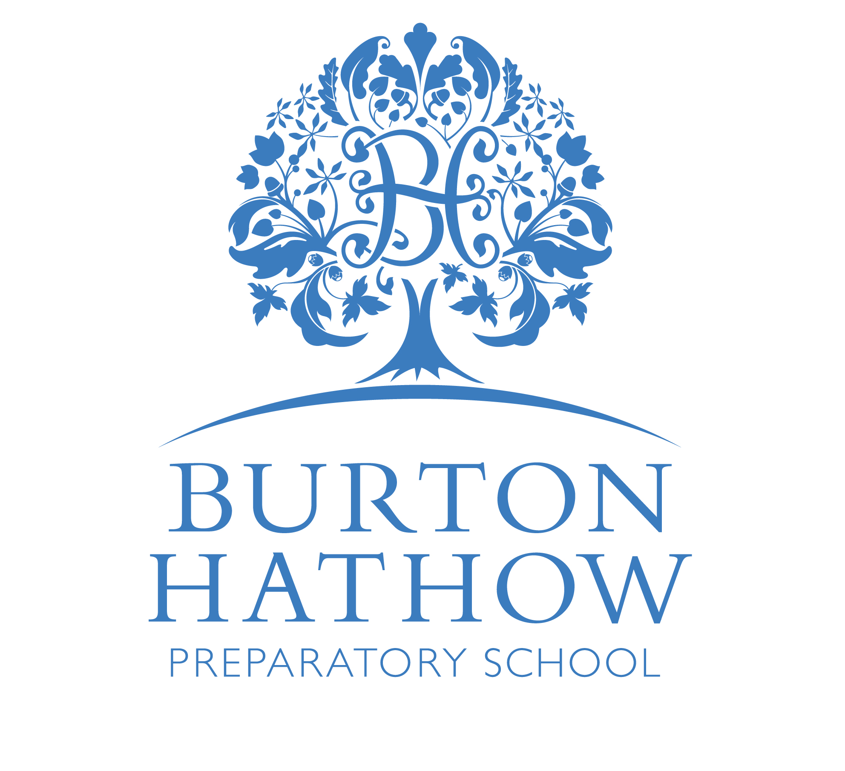
BURTON HATHOW PREPARATORY SCHOOL
Term Dates 2021-22
Autumn Term (1) | Wednesday 8th September 2021 to Friday 22nd October 2021  Holiday: Saturday 23rd October 2021 to Sunday 7th November 2021
Autumn Term (2) | Monday 8th November 2021 to Friday 17th December 2021  Holiday: Saturday 18th December 2021 to Wednesday 5th January 2022  Includes Public Holidays: Monday 27th December, Tuesday 28th December,  Monday 3rd January
Spring Term (1) | Thursday 6th January 2022 to Friday 11th February 2022  Holiday: Saturday 12th February 2022 to Sunday 20th February 2022
Spring Term (2) | Monday 21st February 2022 to Friday 1st April 2022  Holiday: Saturday 2nd April 2022 to Monday 25th April 2022  Includes 2 Public Holidays: Friday15th April (Good Friday) and  Monday 18th April (Easter Monday)
Summer Term (1) | Tuesday 26th April 2022 to Friday 27th May 2022  Includes 1 Public Holiday: Monday 2nd May – May Day Bank Holiday  Holiday: Saturday 28th May 2022 to Sunday 5th June 2022  Includes 1 Public Holiday: Monday 30th May – Spring Bank Holiday
Summer Term (2) | Monday 6th June 2022 to Friday 8th July 2022  School Closed Thursday 23rd June 2022 for Lincolnshire Show
Staff Training Days | Monday 6th and Tuesday 7th September 2021  Wednesday 5th January 2022 Monday 25th April 2022

